# Case Study

## REGISTER

1. Fill in desired username
2. Fill in desired password
3. Fill in password again
4. Click ‘sign up’ button
5. If already have account, click link below to direct to login page.

Exceptional cases:

* If input box is empty: remind message will pops up
* If username already existed in database: alert box will pop up

## LOGIN

1. 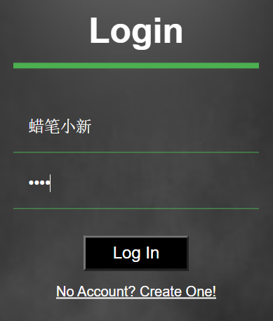Fill in username
2. Fill in password
3. Click ‘submit’ button
4. If no account yet, click the link below to create an account

Exceptional cases:

* If input box is empty: reminder message will pop up
* If user is forbidden: alert box will pop up and prevent user from entering the website
* If username or password incorrect: alert box pops up

## BROWSE HOME PAGE

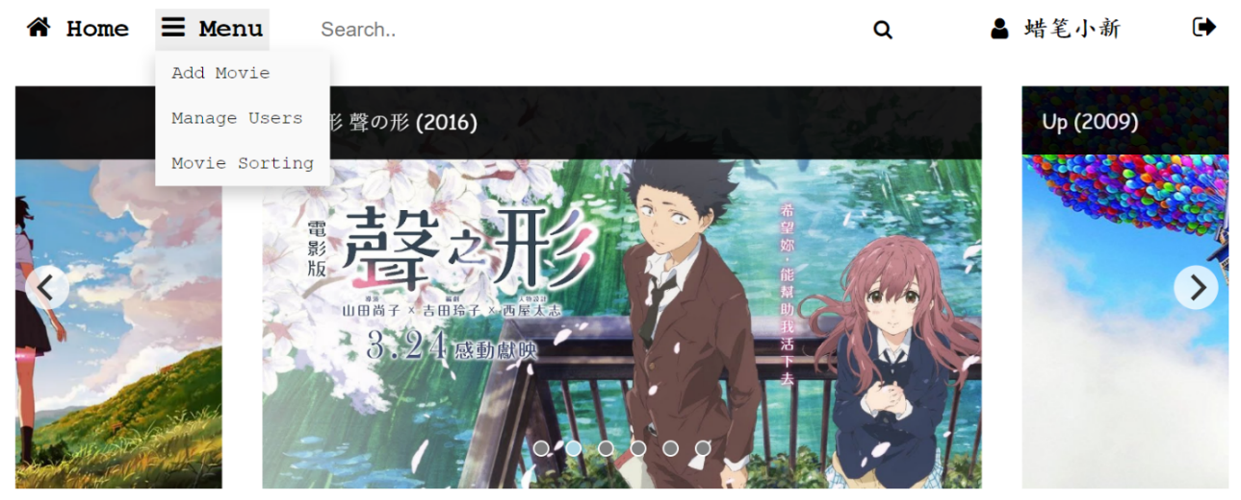

|  |  |
| --- | --- |
| **UI** | **Function** |
| Home button | Return the user to the home page |
| Menu drop down list (privilege dependent)  [User] Movie Sorting  [Admin] Add Movie, Manage Users, Movie Sorting | Add Movie – direct to add and edit movie page  Manage Users – direct to admin page  Movie Sorting – direct to sorting page |
| Search bar | Search movie by keywords |
| User button | Direct to user page |
| Logout button | Logout from the system |
| Carousel movie recommendation feature | Randomly display the movie’s poster and by clicking it, it will direct user to the movie page |

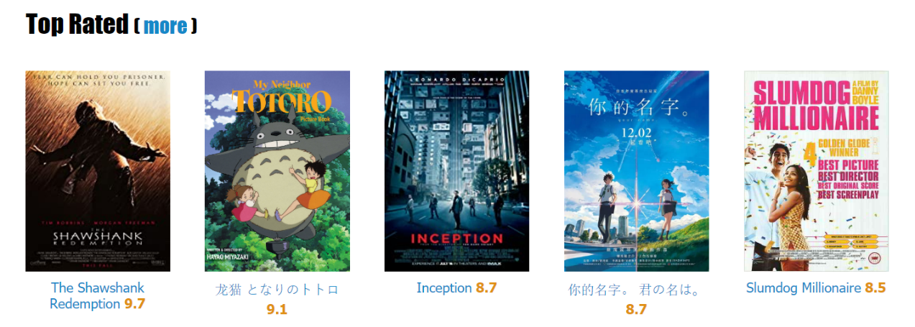

|  |  |
| --- | --- |
| **UI** | **Function** |
| More button | Direct the user to corresponding movie page |

## SEARCH MOVIE



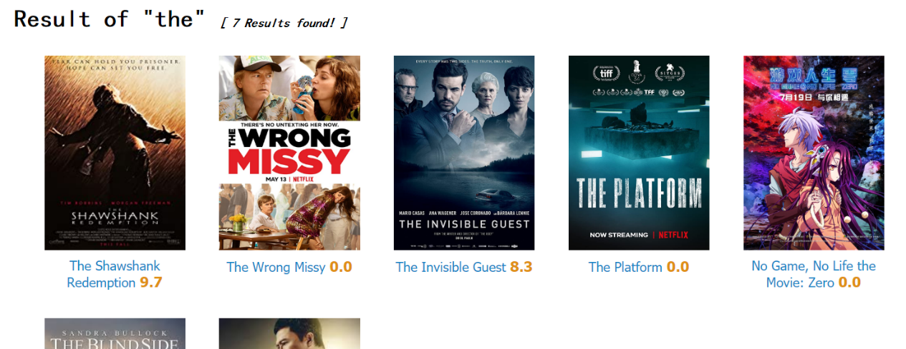

* 1. Enter movie name (partially or fully) on the search bar
  2. Enter or click on the search icon
  3. It will show the results

Exceptional cases:

* Lower and upper case are the same
* If nothing is entered, all of the movies will be shown
* If the movie does not exist, no movies will be shown.

## BROWSE MOVIE

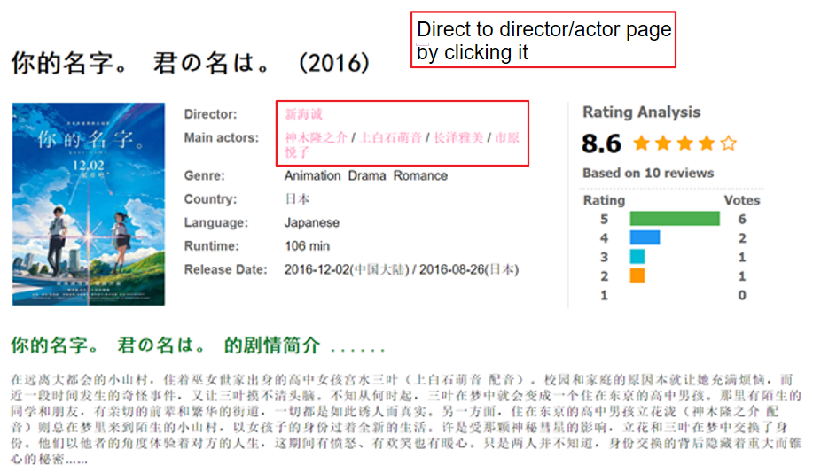

* Browse director/actor page

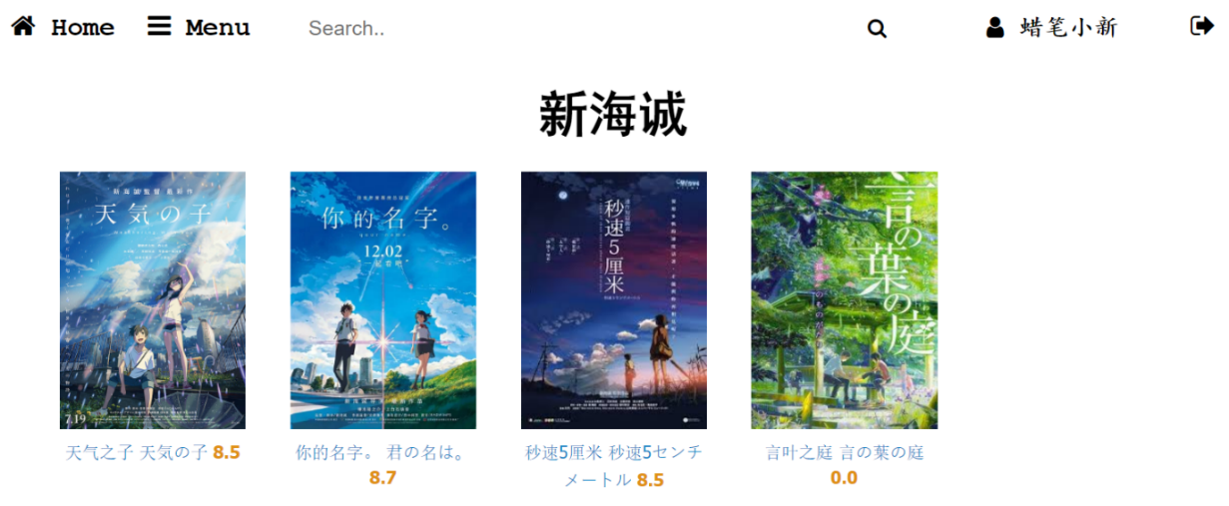

* Add comment (Below the movie description)

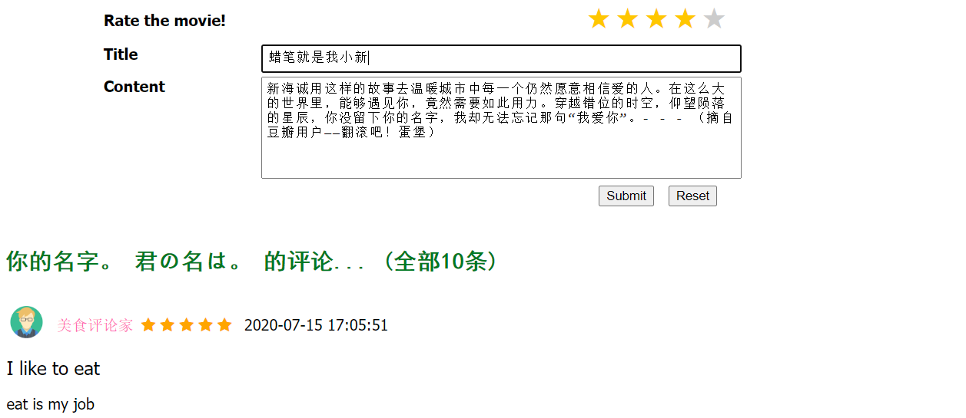

* Edit comment

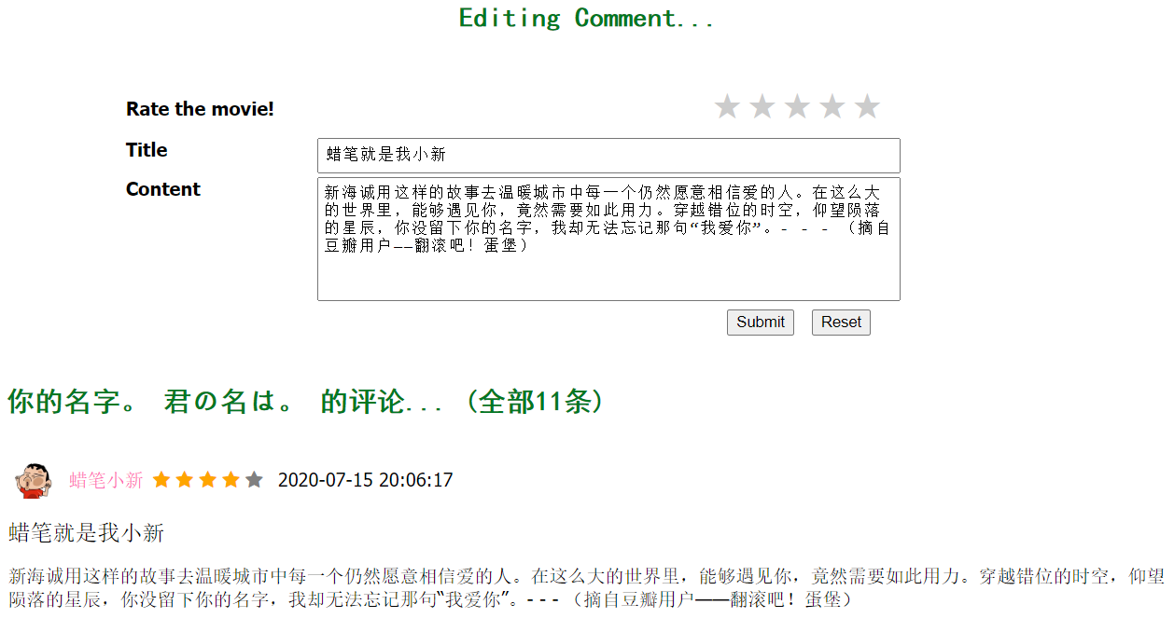

## USER PROFILE PAGE

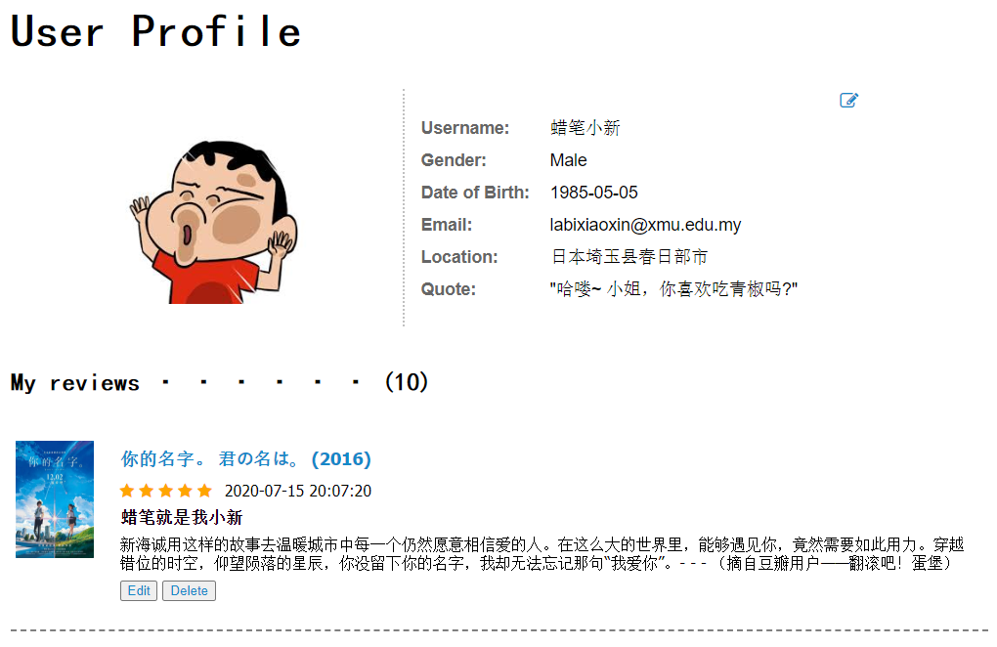

|  |  |
| --- | --- |
| **UI** | **Function** |
| Edit icon | Direct to edit profile page |
| Edit button | Direct to the corresponding movie page so that user may edit it |
| Delete button | To delete the comment user made for the movie |

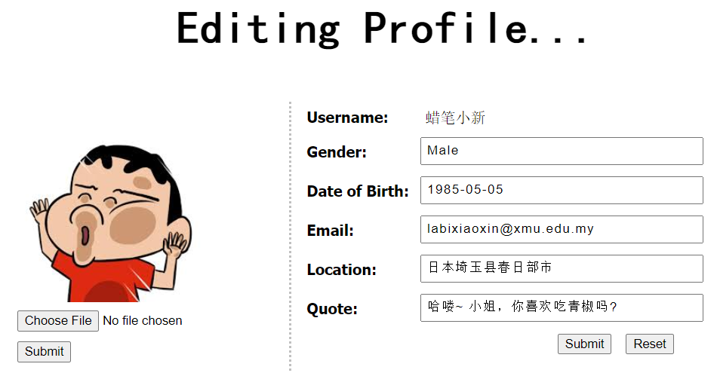

Change Profile Picture

* 1. User may click ‘Choose File’ button to upload only ‘png’ image
  2. Click ‘Submit’ button and the image will appear after a short while

Change Personal Information

* 1. User may edit the information in the text input box
  2. Click ‘Submit’ to apply the changes or ‘Reset’ to reset the default placeholder.

## FILTER/SORT MOVIE

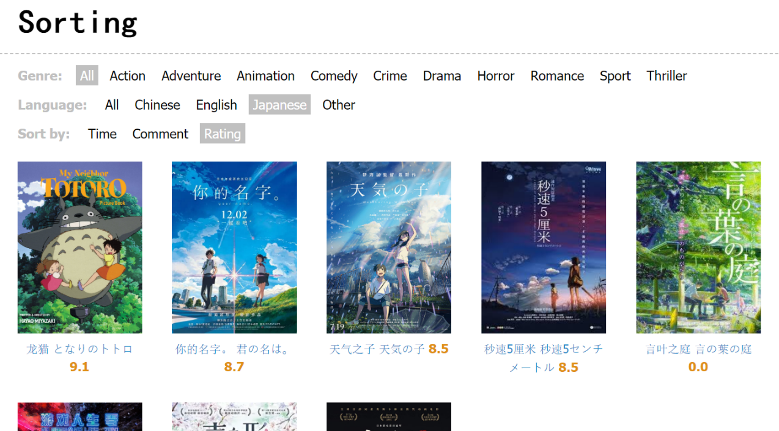

* 1. Choose any filtering combination you wish [Genre, Language, Sort by]
  2. The result will be display in a short while

## ADMIN

* Manage user privilege

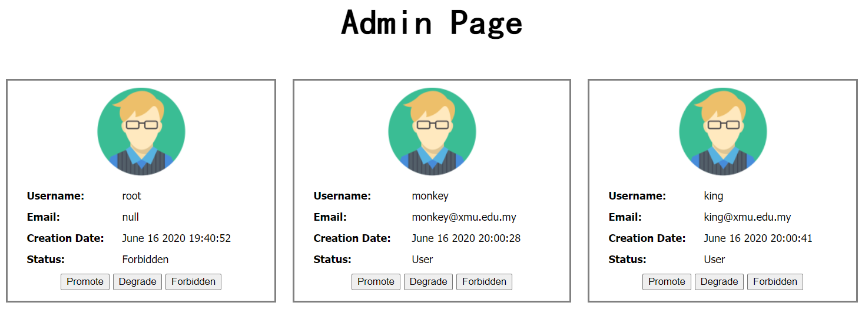

* 1. Free to choose between ‘Promote’, ‘Degrade’, and ‘Forbidden’
  2. The status of selected user will be updated immediately
* Add movie

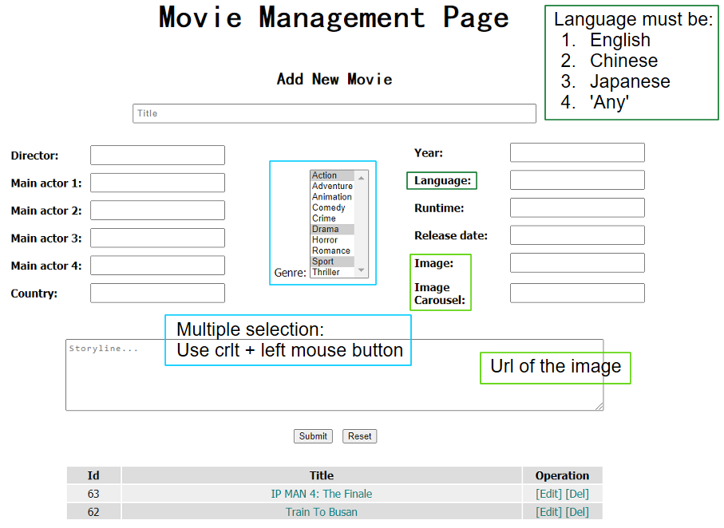

* + 1. Fill in the movie’s detail
    2. Press ‘Submit’ button when completed
    3. New movie will be added and display at the table below
    4. [Bonus] You may edit or delete any movie you want at the table below by clicking the ‘Edit’ or ‘Del’ operation

Exceptional cases:

* If any input box is empty: reminder message will pop up
* For genre: ‘Action’ will be the default option if nothing selected
* If anything, other than ‘Chinese’, ‘English’, ‘Japanese’ was key in in the Language input box: the movie added will be classified as ‘Other’
* Edit movie

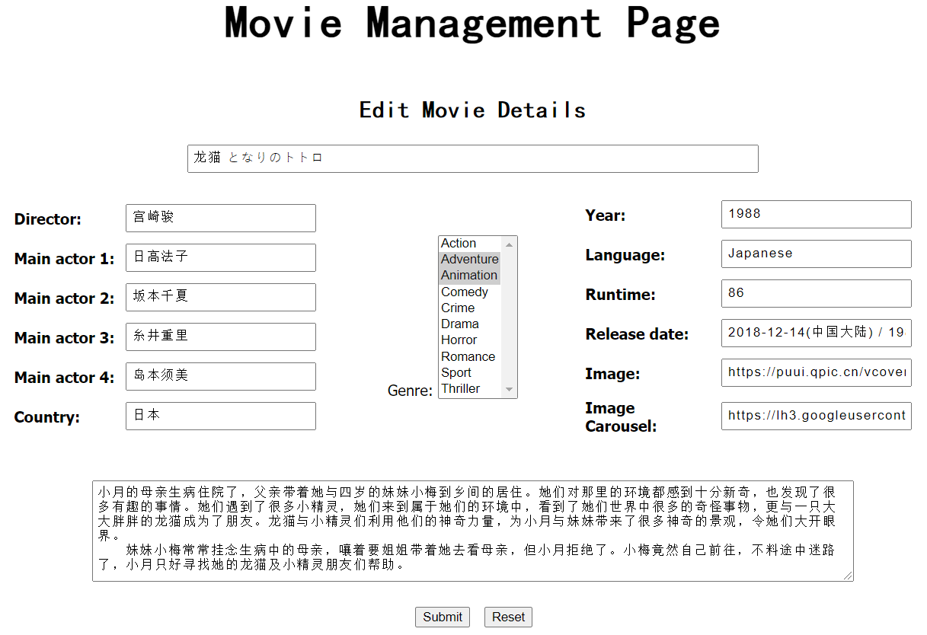

* + 1. The movie detail previously written will be shown
    2. Free to edit any content
    3. Press ‘Submit’ button to make the changes to the database
    4. [Bonus] You may click the ‘Reset’ button to reverse the content back to its original state

Exceptional cases:

* + If any input box is empty: reminder message will pop up